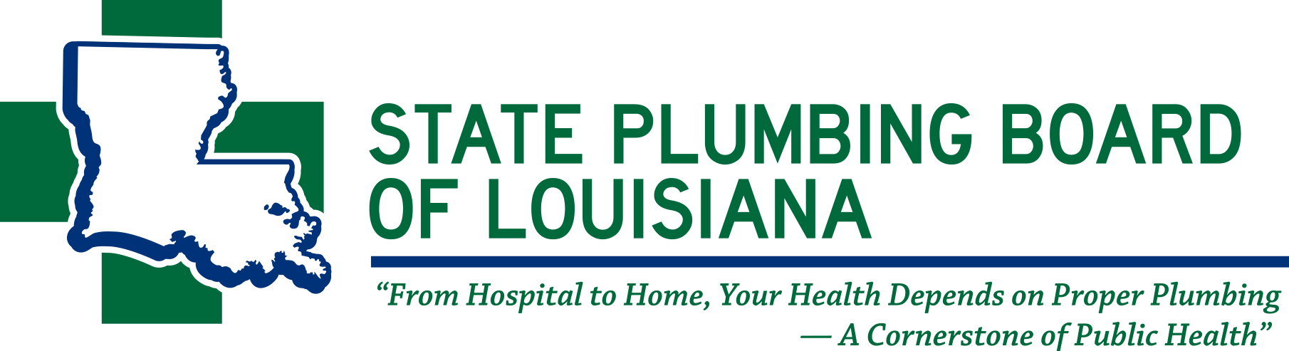
11304 Cloverland Avenue • Baton Rouge, Louisiana 70809
Phone: (225) 756-3434 • Fax: (225) 756-3433
www.spbla.com

BOARD MEMBERS:

TERRY SMITH
CHAIRMAN
BATON ROUGE

KELLY CRAFT
VICE CHAIRMAN
LAKE CHARLES

RICKEY FABRA
SECRETARY/TREASURER
METAIRIE

CARL BOURGEOIS
GONZALES

GERALD LACOUR
ALEXANDRIA

LARRY REILING
COVINGTON

TREY GIGLIO
SHREVEPORT

JAKE CAUSEY
BATON ROUGE

JOHNNIE MARCADE
NEW ORLEANS

ASHLEY J. TULLIER
EXECUTIVE DIRECTOR
BATON ROUGE

TO: BOARD MEMBERS
ADVISORY COMMITTEE MEMBERS
LOUIS ROBEIN/ATTORNEY
ENFORCEMENT OFFICERS
GENERAL PUBLIC

FROM: RULE CHANGE COMMITTEE
CHAIRMAN, CARL BOURGEOIS

SUBJECT: RULE CHANGE COMMITTEE MEETING

The Rule Change Committee Meeting of the State Plumbing Board of Louisiana is scheduled as follows:

DATE: TUESDAY, AUGUST 9, 2022

TIME: 10:00 A.M.

PLACE: PLUMBERS AND STEAMFITTERS’ LOCAL UNION 247
249 MCKEITHEN DRIVE
ALEXANDRIA, LA 71303

Public comment cards will be available to all public attendees.

